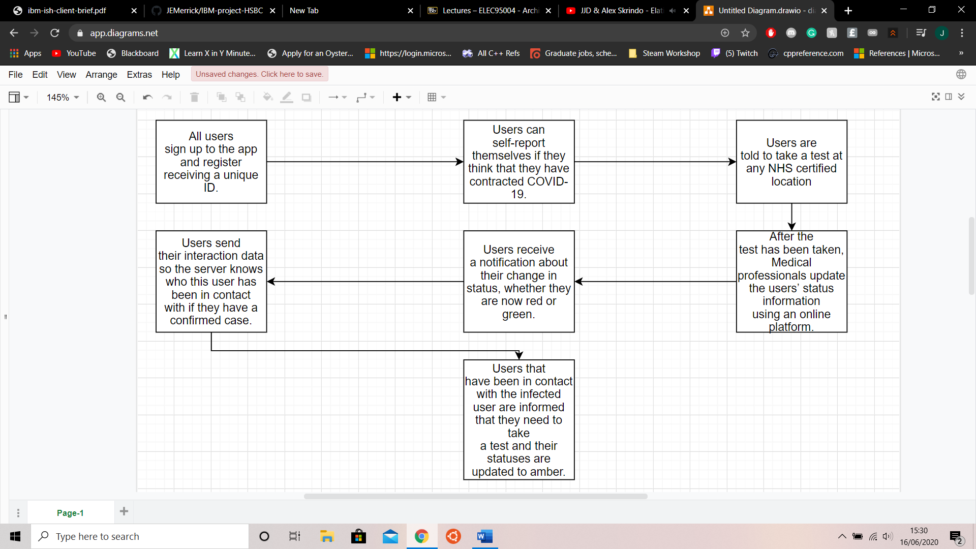

A diagram of our system in practice is shown on the right, which highlights its simplicity. Users download and register with the app which can be found on the Google Play Store and Apple’s App Store. Once registered, the users are given a unique ID. This user ID changes quite often to ensure that there is privacy protection for the user. Whenever the user encounters another person within the Bluetooth’s range over a threshold period, the interaction and relevant information is documented on the user’s phone. These phones store the interaction data and data is stored to the cloud as a backup if anything goes wrong.

Users may self-report suspected contractions of COVID-19. The app then directs them to take a medical test which is booked through the track and trace system, with options ranging from hospitals, drive through clinics, mail order testing services and doctor’s surgeries. Once the test has been taken, the users are immediately alerted of the results as soon as NHS staff update the system with the test results.

If a user is found to have contracted COVID-19, their interaction data is sent to the track and trace system which updates all users’ statuses within a contact cone. These users are told to have a test if they have not previously done so.



Minimises server-side data – we only store the unique ID and status of users.

Reduces load on the system – interactions are only stored and sent on a positive result.

Ease of updates - Medical professionals only need to change the status following test results with integrated software in the batch testing software which automatically updates the users’ statuses.

Autonomous - Any interaction involving an infected user is updated by the system and does not require human interaction.

Minimises workload of users and most of the flow is done by the system.